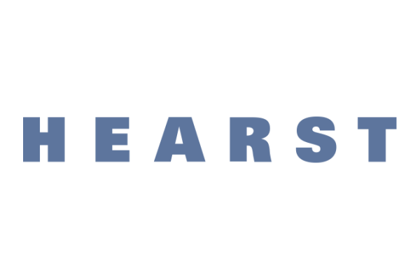

ICYMI: Hearst
_____________________________________________
Not able to make it to the Virtual Career Tuesday with Hearst? No problem! We were there to give you some of the key takeaways for working at Hearst:

Hearst is one of the nation’s largest diversified media, information and service companies. They have 360+ businesses like Cosmopolitan, Roku, and A&E. They also own 21 magazines and newspapers like Houston Chronicle, Times Union, and San Francisco Chronicle.

Hearst Connecticut Media is the local branch of Hearst (#1 in online & print reach in CT). The company is always evolving and acquiring new publications, launching new products and hiring new teams.

They have over 750 sales representatives who conduct digital marketing towards local businesses. Marketers develop and fulfill these goals, while journalists are hired as part of newspaper operations.

Run CTInsider App which provides localized news in Connecticut.

Hearst has a culture of development supported by mentorship and training. Regular trainings and AMAs are held with leaderships, while staffers receive opportunities to attend conferences.

They have active participation in their diversity, equity and inclusion group. This focuses on recruitment & retention, coverage and communications, education and training, as well as outreach and events. They partner with groups in the community to promote this cause.

Candidates should align their resume with their knowledge and experiences that apply to the role. They ask for a cover letter in their application process to show you are a cultural fit.

Newsroom Careers: hiring for weekly/local reporters, trending reporters, digital producers.

Advertising & Marketing Careers: hiring for advertising account executive, sales development representative, customer success manager.

For more info on opportunities and the company, check handshake to connect with Hearst professionals!

Reach out to recruiter Megan Hughes (mhughes@hearst.com) or go to hearst.com/careers for more on opportunities with Hearst.

More information on journalism and the newsroom with Hearst, reach out to Wendy Metcalfe (wendy.metcalfe@hearst.com).

