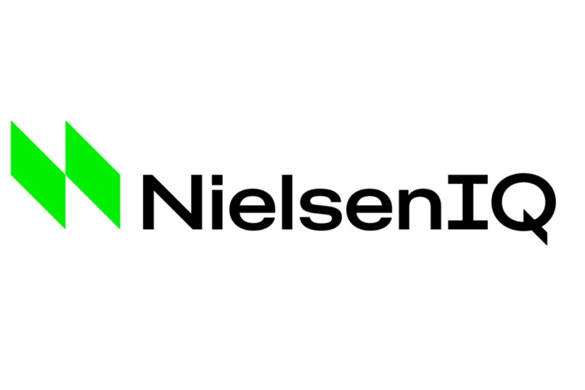
About Company: Retail and consumer data platform that measures shopper behaviors more precisely.
- market research company that helps its clients make objective data driven decisions
- Provides solutions to present “big data” in clear way
- Able to provide strengths and weaknesses of company’s new product
- Able to provide Insight about who the company they are supporting should target and who is purchasing their products
- Can help identify competitors and right offer price for products

Key information presented for students:

Commercial Analyst Internship –
- Use analytical and consultative skills to help clients make better decisions
- Team placements will be across BASES, NIQ’s innovative practice
- Mostly looking to hire for this internship
- BASES –
  - NielsenIQ’s Innovative practice
  - Worldwide leader in analyzing and consulting new

Financial Emerging Leaders Program –
- 24-month rotational program
- Designed to expose you to many aspects of corporate finance
- Exposure to financial planning and analysis, controllership, pricing, and treasury operations
- Also offered as an internship as well

Customer Success Rotational Program –
- Will include 3 rotations across the Customer Success core analytical teams
- Teams are within – Insights, Business Intelligence, and consumer response

Financial Leadership Program –
- A selective 2-year program designed to build finance leaders
- Four 6-month assignments
- Four training courses
- Performance management provided
- Formal mentoring program is included in this program

BASES practice areas –
- Insights
  - Assess the in – market potential of new concepts and products
  - Help clients optimize their initiatives
- Forecasting
  - Utilize consumer response date
  - Planned market execution
- Line & Price
  - Leverage market research and choice-based models to consult clients
- Design
  - Evaluate clients’ current in market packaging
- Demand Solutions
  - Influence strategic planning by assessing foundational category needs
- Advertising Practice
  - Leverage neuroscience tools to help clients understand if their advertising is ready to launch
- Games
  - Customized research with gaming category

Questions asked/answers:
- Main way to apply to their programs is www.ripplematch.com and search for NielsenIQ
- Jobs are also posted on handshake
- There are Spring 2022 co-op, full time, paid internships available
- Easiest way to find applications is to search on ripplematch
- You get a good idea of what the job is like through internship apart of BASES team
- They provide a lot of support, are very flexible, and allows employees to be in position to have client interaction
- Internship program allows for candidates to be hired
- You provided with great training if you do not get a job through the internship program

Interview process/tips for potential candidates:

- Be data driven and have proven, successful experiences leveraging data to tell a story or drive results
- Possess critical thinking skills
- Have strong organizational skills
- Be creative and willing to think outside of the box
- Have strong written and verbal communication skills
- Be able to collaborate effectively with internal teams to execute projects
- Have an interest in consulting
- Have an interest in the consumer-packaged goods industry
- Interview –
- Phone Screening
- Virtual interview – Hirevue
- Analytical assessment
- Panel interview -
- Mix of behavioral and analytical questions
- Brief case study

- They will look at LinkedIn during hiring process
- If given the option to provide a cover letter, do so

Other:

Recruiter emails:

ashley.lane@nielseniq.com
megan.lynch@nielseniq.com
kimberly.loughery@nielseniq.com

