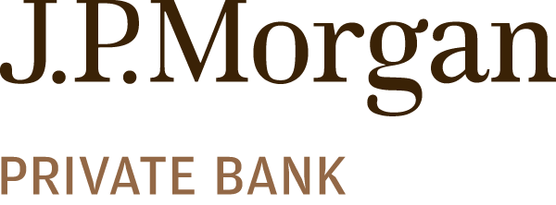

About Company:
- The private bank has been known to have teams of advisors that help clients achieve their goals by delivering the right solutions and services across investments, credit and banking. Their dedicated specialists also provide industry-leading advice in financial planning, estate planning, tax planning and philanthropy.
  - They have $1.7 Trillion in assets
  - 2400 + client advisors worldwide
  - Consistently ranked as the best private bank in the world
  - They have clients in the U.S, Europe, Latin America, and Asia

Key Information presented for students:

- What they do:
  - Wealth Planning –
    - Conduct analyses and projections to inform decision making
    - Estate planning
  - Lending –
    - Model cash flows and develop strategies to bridge gaps or pursue investments
    - Structure complex credit strategies
    - Unlock sources of liquidity
  - Investing –
    - Manage yield on client’s existing liquid assets
  - Banking –
    - Streamline day to day financial management
- Summer internship program –
  - Nine-week program that begins In early June and concludes in early August
  - Top performers may receive full time offers at the end of the summer
  - You will have the opportunity to work with teams to understand the client’s needs and examine market activities to develop strategies
  - Given the opportunity to learn about the business and their clients
  - One on one mentorship will be provided
  - Applications are currently open and close on October 2nd
  - Must be a Junior or Senior
- Class of 2025 opportunities –
  - Advancing Black Pathways & Advancing Hispanics and Latinos Fellowship Program
    - 6-week immersion program for students that identify as black and/or Latinx
    - High likelihood of offer into 2024 summer analyst program fellowship

Interview process/tips for potential candidates:

- Application Process –
  - Submit application online through their JPMC careers website
  - First round interview - Hirevue
  - Final round will be a super day that will take place in June – November
Questions:

- They are looking for leadership skills, General understanding of the financial industry
- When reaching out to people at JPMC on LinkedIn lets business member to talk about themselves
- Possible to get an offer in the market you intern in or get a recommendation to go elsewhere

Other:

- Recruiter email – carolinegrace.williams@jpmorgan .com

