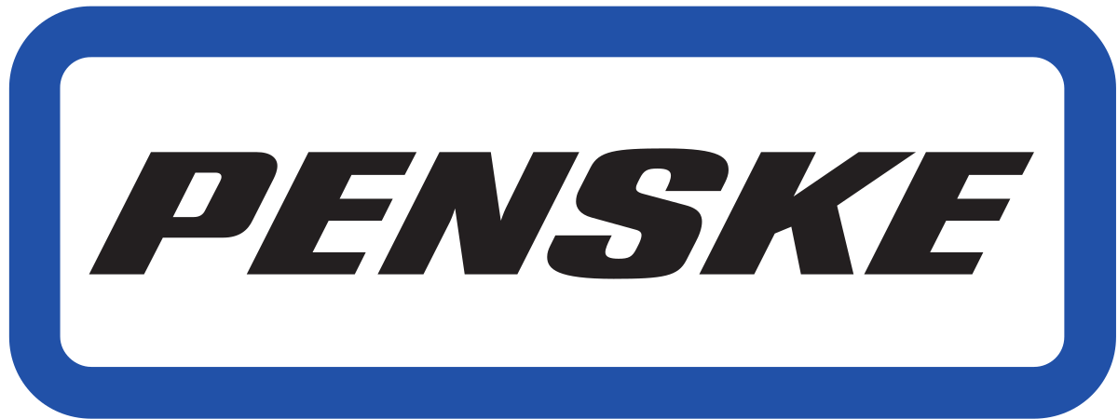

About Company:

- Penske is a privately held, diversified, on-highway, transportation services company that has subsidiaries operating in a variety of industry segments, including retail automotive, truck leasing, transportation logistics and professional motorsports.

Key Information presented for students:
- They are currently recruiting for:
  - Sales
    - Build relationships with customers
    - Contact other businesses
    - Consulting
    - Record and account maintenance
  - Operation management trainees
    - Candidates will develop consumer and commercial customer solutions for local and national accounts
    - Manage and oversee large fleet of vehicles
    - Generate business leads
    - Receive ongoing training and mentoring
    - Collaborate with high energy team
  - Finance
  - Maintenance coordinators
- Typical day –
  - Sales and management trainee will work in rental department
  - They will have the opportunity to work with manager,
  - Trainees will have the opportunity to shadow different areas, will have training at corporate offices,
  - Will usually be taking inbound phone calls,
  - Role is client facing
- Penske Truck Leasing –
  - Consumer Rental
  - Commercial Rental
  - Contract Maintenance
  - Full-Service Lease
  - All candidates start at the management trainee position, transition to assistant rental manager then to whatever career path they want

Questions:
- They are in supply chain management
- They are very inclusive
- They listen to associates to improve the company

Interview process/tips for potential candidates:

- Interview with district manager typically one person, sometimes two
- Understand what you want and what drives you
- Interviewers are looking for candidates that are:
  - Well spoken
  - Team players
  - Hard workers
- Have a big vision for yourself within the company
- Understand the long-term goal of the company
- When going in for an interview be able to talk about yourself
  - Talk about your strengths
  - Build up your experiences
  - Relate experiences to the role that you are going for
- Have an elevator pitch for the interview to make yourself stand out
- Know at least the minimum amount about the company and how the current economic atmosphere is affecting the company
- Show that you are investing in yourself:
  - Reach out to recruiters using LinkedIn or other method of communication

Other:
Field Sales Manager – Holly Bartoletti
Holly.Bartoletti@Penske.com

Sales director – Dan Donnelly
Dan.donnelly@penske.com

